## MICROPROCESSOR BASED SYSTEM DESIGN

**TASK 08**



## Spring 2022 CSE307 MBSD

Submitted by: **Ashfaq Ahmad** Registration No. : **19PWCSE1795** Class Section: **B**

Student Signature:

Submitted to:

## Dr. Bilal Habib

Monday, June 27, 2022

**Department of Computer Systems Engineering University of Engineering and Technology, Peshawar**

**Task:**

Design the following four waveforms: all of them have 150Hz frequency

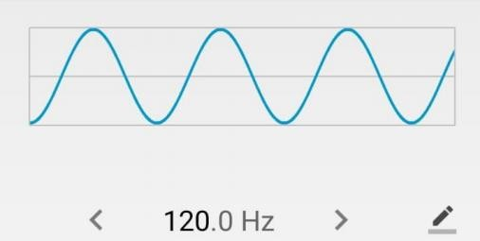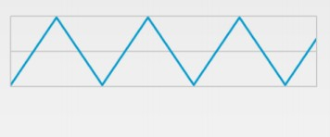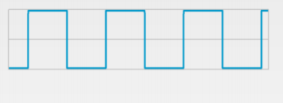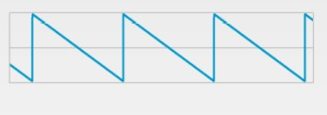

**Problem Analysis:**

**DAC:**

DAC is used for digital to analog conversion. We will be using DAC0808 in this task. DAC0808 has 8-bits digital input and it converts this input into analog. It has Iout and Vref pins. Formulas for DAC:

Iref = Vref / R

Iout = Iref(D7/2 +D6/4 +D5/8 +D4/16 +D3/32 +D2/64 + D1/128 + D0/256)

Vout = Iout*R

TMOD:

Timer1 Timer0

Gate C/T M1 M0 Gate C/T M1 M0 0 0 0 0 0 0 0 1 (Hex= 1)

Timer 0: Used as Timer with mode 1

|  |  |  |  |  |  |  |  |  |
| --- | --- | --- | --- | --- | --- | --- | --- | --- |
| IE: | EA | -- | -- | ES | ET1 | EX1 | ET0 | EX0 |
|  | 1 | 0 | 0 | 0 | 0 | 0 | 1 | 1 |

**Timer 0 (Used as timer in Mode 1):**

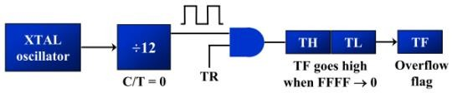

# Code:

#include <reg51.h>

#include <stdio.h>

unsigned char counter1 = 0;

void delayFun(unsigned char Hi, unsigned char low){

TMOD=0x01;

TL0=low;

TH0=Hi;

TR0=1;

while (TF0==0);

TR0=0;

TF0=0;

}

void init()

{

EA = 1;

EX0 = 1;

IT0 = 1;

}

void Interrupt1(void) interrupt 0

{

counter1++;

}

void main(void)

{

init();

while (1)

{

if (counter1 == 0 )

{

while (1)

{

unsigned int sineWave[] = {118, 182, 228, 253, 231, 202, 125, 74, 16, 20, 16, 64, 138};

unsigned char j;

for (j = 0; j < 12; j++)

{

P1 = sineWave[j];

delayFun(0xFE,0X34);

}

if (counter1 == 1 )

break;

}

}

else if (counter1 == 1 )

{

while (1)

{

unsigned int j;

for (j = 0; j < 255; j++)

{

P1 = j;

}

for (j = 255; j > 0; j--)

{

P1 = j;

}

delayFun(0xFE,0X34);

if (counter1 == 2 )

{

break;

}

}

}

else if (counter1 == 2 )

{

while (1)

{

P1 = 0x00;

delayFun(0XF1,0X9A);

P1 = 255;

delayFun(0XF1,0X9A);

if (counter1 == 3 )

break;

}

}

else if (counter1 == 3 )

{

while (1)

{

// FOR SAW TOOTH WAVE

unsigned int j;

for (j = 255; j > 0; j--)

{

P1 = j;

delayFun(0xFE,0X34);

}

if (counter1 == 4 )

{

counter1 = 0;

break;

}

}

}

}

}

# Output:

## Schematic:

**Sine Wave (Button not pressed) :**

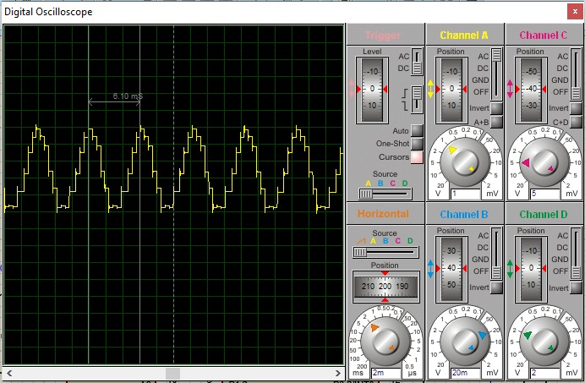

## Triangular Wave (Button pressed once):

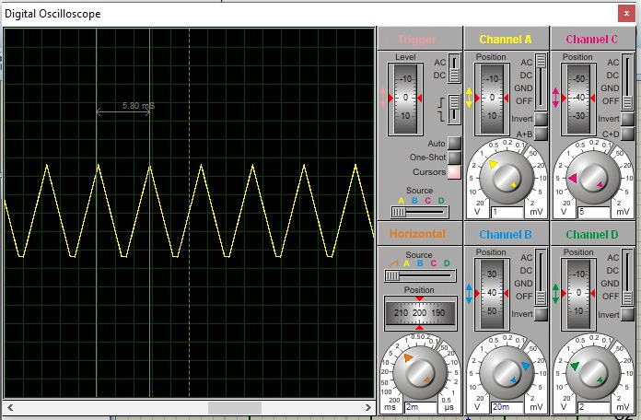

**Ramp Wave (Button pressed twice):**

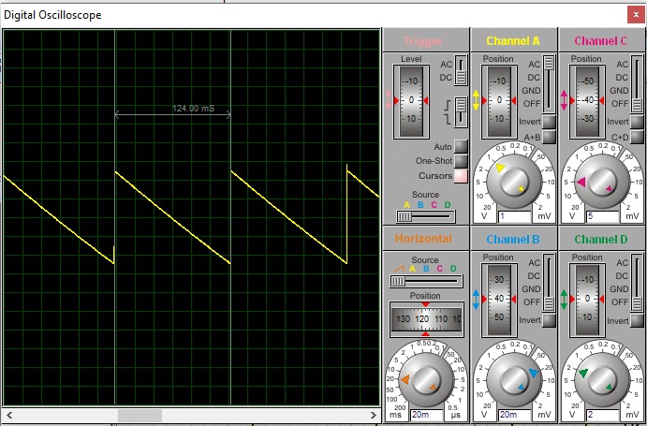

## Square Wave (Button Pressed trice):

